Scoil Naomh Mhuire, Muchgrange, Greenore, Co. Louth
2024
Special Education Needs Policy

Introduction

Scoil Naomh Mhuire is a co-educational mainstream primary school, catering for a full cross section of children. The purpose of this SEN policy is to provide practical guidance for teachers, parents and other interested parents on the provision of effective learning support to pupils with special needs, pupils experiencing low achievement or learning difficulties, as well as to fulfil our obligations under the Education Act 1998 and EPSEN 2004.

Our school currently has the following provision of staff to cater for children with Special Education Needs:

• One full time SET
• 1 job share SET/EAL teacher
• 2 full-time Special Needs Assistant and 1 part-time Special Needs Assistant. (Infant day)

The school will engage in careful timetabling of these resources to ensure certain aims, including:

- Making sure children, including children with special educational needs, can access their constitutional right to education.
- Providing a level and quality of education appropriate to the needs and abilities of children in our school, as far as is practicable with the resources available.

To provide an education appropriate to the child’s needs, parents are required to submit all medical/psychological/educational reports to the school, to support an application for resources to the Department of Education and Skills, to meet the needs whether physical, psychological, educational, behavioural, emotional, social or medical.

The principal aim of Learning Support through SET is to optimise the teaching and learning process to enable pupils with learning difficulties to achieve adequate levels of proficiency in literacy and numeracy before leaving primary school. Access to support is also offered to children who may be experiencing behavioural, emotional or social difficulties and to EAL children.

Review

This Policy will be reviewed every third school year, or as circumstances may warrant. (2027)

Inclusiveness
Our school enrolment policy supports inclusiveness with reference to the enrolment of children with special needs (whether physical, physiological, educational, behavioural, emotional, social or medical). Children with special needs will be resourced in accordance with the level of resources provided by the Department of Education and Skills to the Board of Management.

We believe that pupils with needs belong in our school and deserve the very best educational opportunities.

Key Initiatives Supporting Inclusion:

- The National Council for Special Education (NCSE):
  - Established to support the inclusion of children with special educational needs. It provides guidelines, resources, and Special Needs Assistants (SNAs) to help schools create inclusive environments.
- The Comprehensive Strategy for Special Needs Assistants (SNAs):
  - The role of SNAs is to support the care needs of students with disabilities, and they are an integral part of the inclusion model in schools.
- School Inclusion Model (SIM):
  - The SIM is a pilot model introduced by the Department of Education, providing a multidisciplinary approach to support children with special needs. It includes SNAs, therapists, and additional resources for schools to support inclusion.

Key Principles of Inclusion:

- Ensuring that all children can learn and participate fully in the life of the school.
- Providing differentiated learning and teaching strategies to meet the individual needs of students.
- Promoting positive behaviour support to help manage challenging behaviour in a supportive and non-punitive way.
- Ensuring that all staff receive appropriate training in inclusion and special educational needs.

Every effort will be made to support staff in availing of professional development opportunities in special needs. This can be done through:

• In-service for whole school staff e.g., attendance by Educational Psychologists at staff meetings or staff development, in-service days, working with facilitators from the PDST on various subject areas
• Providing opportunities for special education teachers to attend in-service training, seminars and support groups
• Supply books for library on specific areas of relevance to special education i.e., Dyspraxia, Dyslexia, Down Syndrome, Asperger’s, ADHD, Behaviour difficulties, etc.

Communication:

This policy will be available on our school web site.

Specific Objectives of Learning Support

Through the implementation of this policy, we strive to:

• Facilitate pupils to participate in the full curriculum for their class level.
• Develop positive self-esteem and positive attitudes to school and learning.
• Enable pupils to monitor their own learning and become independent learners within their own ability.
• Involve parents in supporting their children’s learning.
• Promote collaboration among teachers.
Guiding principles:
Education for Persons with Special Educational Needs Act 2004 -

Under the Education for Persons with Special Educational Needs (EPSEN) Act 2004, children with special educational needs should be educated in an inclusive setting, unless this would:

- Not be in the best interests of the child, or
- Not be in the best interests of effectively providing education for other children in mainstream education.

The Act provides that:

People with special educational needs are educated in an inclusive environment, as far as possible.
People with special educational needs have the same right to access and benefit from education as children who don’t have these needs Parents have more involvement in the education of their children and decision making.

The Irish Constitution sets out the role of the State and the rights of parents in providing education. All children have a constitutional right to free primary education up to the age of 18, including children with special educational needs. The school recognises that effective learning programmes are based on the following principles:

• Effective whole-school policies
• Whole school involvement
• Prevention of failure at infant level – early intervention.
• Provision of intensive early intervention up to and including second class
• Direction of resources towards pupils in greatest need.

National Council for Special Education (NCSE)

The National Council for Special Education was set up to improve the delivery of education services to persons with special educational needs arising from disabilities with particular emphasis on children. The NCSE is responsible through its network of local Special Educational Needs Organisers (SENO) for allocating SET hours and SNA/special needs assistants to support children with special needs.

Provision of SNAs

Special Needs Assistants are allocated to the school based on the current needs of pupils attending. SNAs play an important role in supporting children with learning, physical or behavioural difficulties. The role of an SNA in the classroom involves assisting the teacher to support students with special educational needs who may also have significant care needs.

NCSE – ‘Special needs assistants (SNAs) play an important role in assisting the teacher to support students with special educational needs who have significant care needs. They are allocated to the school and work under the direction of the principal/teachers. The SNA usually supports a number of students with care needs in the school. Most students with special educational needs do not have significant care needs and therefore will not need access to a special needs assistant while at school.’

From the Special Needs Assistant (SNA) Scheme Information for Parents/ Guardians of Children and Young People with Special Educational Needs.

Prevention Strategies:

As a means of preventing the occurrence of learning difficulties as far as possible, the following strategies are being implemented:

• The development and implementation of agreed whole school approaches and policies, e.g. phonological awareness, ‘talk time,’ in Maths and Literacy.
- The updated curriculum places a strong emphasis on oral language development as the foundation for literacy skills, fostering confidence and fluency in communication.
- Teaching of other aspects of the new for curriculum for English and Maths with an emphasis on Play and Inquiry-Based Learning: Especially for younger children, to engage students actively and creatively, fostering curiosity and critical thinking skills.
• The development and implementation of agreed whole school approaches to the teaching of aspects of Maths, e.g. our whole school approach to ‘Daily Counting,’ and ‘Maths journals’ for self-assessment.
• Promotion of parental understanding and involvement through consultation with parents, information on policy and events through the school website and the arrangement of formal and informal Parent-Teacher Meetings.
• Class based early intervention by Special Education Teachers from Infants to Rang 6 resulting in the provision of additional individualised support. In JI this will be primarily focused on identification of pupils with emerging needs who may need support, and team teaching of literacy and Numeracy on a six-week rota with each class group.
• Ongoing observation and assessment of pupils by the Class Teacher and SET.

Selection of Pupils for Learning Support:

• The principle of Early Intervention applies, therefore pupils from Senior Infants to Second Class are given priority in the allocation of Learning Support.
• In Junior infants, pupils are screened using teacher and SET observation.
• From Senior Infants upwards, all pupils are screened annually, using appropriate standardised tests.
• Priority for Learning Support is given to those pupils who perform at or below the 12th Percentile, excluding in the main pupils who receive support from SET.
• In the case of pupils performing at or below the 12th percentile, the screening process is followed by a consultative meeting between the Class Teacher, the SET and the parents concerning the pupil’s performance, and supplementary teaching is offered
• In the allocation of places for Learning Support, the following are prioritised:

- Senior Infants identified by the Class Teacher, through Teacher Observation and MIST or other screening instruments, as having difficulty in literacy
- Children from Rang 1 and Rang 2, at or below the 12th percentile in literacy
- Children from Rang 3-Rang 4 at or below the 12th percentile in literacy
- Senior Infants, identified by the Class Teacher, through Teacher Observation and/or MIST or other screening instruments, as having difficulty in numeracy
- Children from Rang 1 and Rang 2, at or below the 12th percentile in numeracy
- Children from Rang 3 and Rang 4, at or below the 12th percentile in numeracy
- In class support for children presenting at 12th to 20th percentile in literacy and numeracy in all classes up to Rang 4.

Continuum of Support for SSP

Our school will use the ‘Continuum of Support Process’ as outlined below. Identification of educational needs is central to setting suitable learning challenges for our special educational needs. Using the continuum of support framework, our school will identify pupils’ educational needs to include academic, social and emotional needs, as well as needs associated with physical, sensory, language and communication difficulties. It is important to look at a pupil’s needs in context, and to use our resources to support this (for example, learning environment checklist, teacher checklist for whole-class structures and supports).

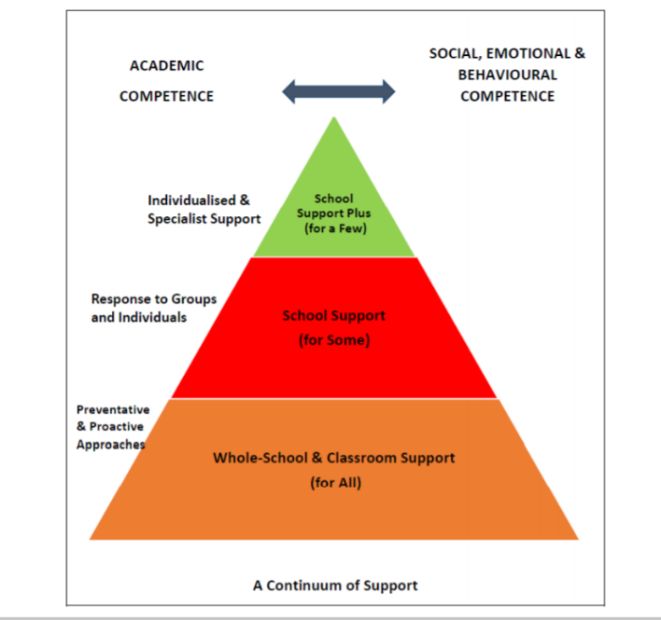

The Continuum of Support is a problem-solving model of assessment and intervention that enables us to gather and analyse data, as well as to plan and review the progress of individual pupils. These actions are identified using a problem-solving approach. An incrementally more systematic process is outlined depending on where the pupil s needs lie on the continuum in terms of intensity and duration. This problem-solving process is illustrated as follows:

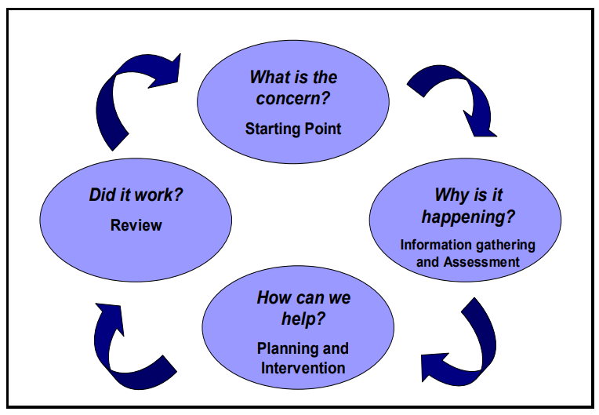

– Student Support Plans –

The SSP and folder will address the pupils’ full range of needs and will include:

Details from the Class Teacher
Assessment Results
Other relevant information, e.g. reports from other agencies
Learning strengths and attainments
Priority Learning Needs
Learning Targets
Class based Learning Activities
Supplementary support activities to include ICT
Home Support Activities:

Each plan will be monitored through teacher observation; the keeping of planning and progress records and through the pupil’s own feedback.

A detailed review will take place at the end of each Term. If requested, SET and/or the Class Teacher will meet the parents to discuss the child’s progress in the light of the review.

Provision of Supplementary Teaching

•The primary work of SET is the provision of supplementary teaching to the pupils identified above
• The school year will be divided into Instructional blocks for whole class support of Literacy and Numeracy of approximately 6 weeks each.
• The maximum case load at any one time shall be 30 pupils
• One to one teaching may be provided where small group teaching has not been effective.
• A system of withdrawal and/or in-class support (team teaching) will operate in response to the needs of the individual pupil.
• The Class Teacher and the Learning Support Teacher will meet to devise a Student Support Plan (SSP), in consultation with the principal and parents. The pupil involved can also contribute to setting their own input via ‘My Thoughts About School,’ document.
- SET will use all information gathered to create short-term SMART targets for pupils.
• If the pupil is in receipt of support from a SET to address other needs, e.g. behavioural problems, sensory difficulty, it may be appropriate for the SET to provide supplementary teaching as well.

• The SET will maintain the following documentation in individualised files:

  - SSP and Learning programme
  - Short term planning
  - Other records, e.g. tape recordings of oral work
  - Samples of written work for assessment
  - Reading analysis records through Accelerated Reader.

Timetabling

•The provision of support is in addition to the regular class teaching in English and Maths
•Effort is made to ensure that pupils do not miss out on the same curricular each time they attend support. A flexible approach to timetabling is adopted by the Class Teacher, though class disruption must be minimised.
•The provision of Learning Support may include withdrawal of pupils from their classroom and/or in-class tuition.
•In class support, if appropriate, will be jointly designed and monitored by the Class Teacher and the SET.

Provision of Resources

•Resources for the provision of Learning Support include a variety of textbooks, library books and ancillary materials and oral language development materials. A variety of testing materials are also in use which include standardised, diagnostic, screening, reading experience, reading attainment, phonological awareness and Maths attainment.
•Following consultation between the Learning Support Teacher, Principal and Class Teacher, funding for materials may be available through the Board of Management and through the School Lotto fund.
•Support resources will primarily be used in the learning Support Room. These resources may be made available to Class Teachers following consultation with the Learning Support Teacher.

Continuing and Discontinuing Supplementary Teaching

•In general, children should not stay for more than 2 years in Supplementary Teaching, unless they are still at or below the 12th Percentile
•Following the end of Instructional Term review as detailed above, a decision is made to continue/discontinue the provision of Supplementary Teaching.
•The decision-making process involves consultation between the Class Teacher, the Learning Support Teacher, and the pupil’s parents, and account is also taken of the overall Learning Support demands in the school.

•The criteria on which the decision will be made include:

- A consideration as to whether the pupil has achieved some/all the learning targets set
- A consideration as to whether the pupil will be able to cope independently/semi independently in the classroom learning context
- A decision to continue the provision of supplementary teaching will result in a revision of the SSP.

Referral to out of School Agencies

•The Learning Support Teacher co-ordinates the referral of pupils to outside agencies, e.g. Educational Psychologists, NEPS, NCSE etc…
•The Principal, SET and Class Teacher meet with the parents to discuss the need for the referral and to seek consent.
•The Class Teacher completes the necessary referral form in consultation with the appropriate school personnel.
•The external professional visits the school to meet with the pupil, parents, principal, Class Teacher and the Learning Support Teacher as appropriate, and the assessment is conducted
•This is followed by a meeting at which findings are discussed, recommendations are considered, and an appropriate response is agreed.
•Where concern arises regarding the manner of speed of the follow-through post assessment, such concern is pursued by the Principal with the out of school agency concerned.

Staff Roles and Responsibilities:

Special Needs Support is a collaborative responsibility shared by all partners in the learning experiences. It is important that all partners contribute to the planning and implementation of our school plan on SEN.

Board of Management-

The role of the Board of Management is to:

•Oversee the development, implementation and review of the provision of SET in the school.
•Ensure adequate classroom accommodation and teaching resources are provided for the SET.
•Provide a secure facility for storage or records in relation to pupils in receipt of Learning Support.
•Budget for ongoing support for Professional Development in Learning Support for staff.

Principal

The role of the principal is to:

•Assume overall responsibility for the development and implementation of the school’s policy on SET and special needs provision in co-operation with the Board of Management, Teachers, parents and children.
•Work with teachers and parents in the development of the school plan on learning support in the context of Special Needs Education.
•Monitor the implementation of the school plan regarding Special Needs on an ongoing basis.
•Monitor the selection of pupils for supplementary teaching, ensuring that this service is focused on the pupils with lowest levels of achievement.
•Assume direct responsibility for co-ordination learning support in the context of Special Needs Services.
•Oversee the implementation of a whole-school assessment and screening programme to identity pupils with very low achievement and learning difficulties so that these pupils can be provided with the support they need.
•Keep teachers informed about the external assessment service that are available and the procedure to be followed in initiation referrals.
•Help teachers increase their CPD and knowledge of learning support.

Class Teacher

The class teacher has primary responsibility for the progress of all pupils in his/her class, including those selected for supplementary teaching. In supporting the development and implementation of the school plan on SEN, the class teacher should:

•Implement teaching programmes which optimise the learning of all pupils and to the greatest extent possible prevent the emergence of learning difficulties.
•Implement the school policies on screening and selecting pupils for supplementary teaching in English and Maths by co-operating and assisting with the administration and scoring of appropriate screening measures.
•For each pupil who is in receipt of supplementary teaching, to collaborate with the Learning Support Teacher in the development of an individual profile and learning programme by identifying appropriate learning targets and by organising classroom activities to achieve these targets.
•For each pupil who is in receipt of supplementary teaching, to adjust the classroom programmes in line with the agreed learning targets and activities.
•Plan of work in English and Maths to be provided to the SET in advance.

Regarding teaching pupils with low achievement, the following general approaches and methods are recommended:

•Such children should be prioritised when accessing information from previous class teacher.
•Priority when establishing parental contact.
•Team teaching.
•Modify presentation and questioning techniques to maximise the involvement of pupils with low achievement in class activities.
•Placing emphasis on oral language development across the curriculum.
•Providing pupils with extra tutoring in the key basic skills in literacy and numeracy.
•Setting learning targets at an appropriate level.
•Providing learning activities and material which are suitably challenging, but which also ensure success and progress.
•Carrying out error analyses of a pupil’s work to pinpoint specific areas of difficulty
•Setting up ‘buddy systems’ in class (high achievers collaboratively working with low achievers, e.g. peer tutoring / paired reading.
•Applying assessments and tests which offer challenge and opportunities for success to children of all levels of achievement.

A key role of successful SET is a very high level of consultation and co-operation between the Class Teacher and the SET. Central to this consultation is the development, implementation and review of SSPs.

Special Educational Teacher:

The role of the SET is to:

•Provide small group withdrawal, in-class small group support, in-class 1:1 support, station teaching for early intervention, in-class support for larger targeted group or class interventions. Teaching both academic and non-academic areas.

- Take a lead role in developing Student Support Plans and learning targets for each pupil who is selected for supplementary teaching in consultation with the Class Teacher and parents.

•Maintain and planning and progress record or equivalent for each individual or group of pupils in receipt of support.
•Provide teaching in English and Maths to pupils in the school who experience low achievement, in accordance with the school’s selection criteria
•Contribute to the development of policy on Learning Support at whole school level.
•Provide advice to the Class Teachers in such areas as individual pupils assessment and programme planning, as well as approaches to language development, reading, writing and mathematics for pupils experiencing difficulties.
•Contribute at school level to decision making regarding the purchase of learning resources and materials to be made available to pupils with learning difficulties in their mainstream classrooms and in the Learning Support room.
•Perform a defined role in co-ordinating the provision of Special Needs services in the school.
•Liaise with external agencies such as psychologists, NCSE and NEPS to arrange assessments, assistive technology and special provision for pupils with special needs.
•Maintain a list of pupils who are receiving supplementary teaching and special education support.
•Track the progress pupils who have discontinued support.

Parents

The role of parents supporting the Learning Support for their children is vital to its success. Specifically, parents contribute through:

Regular communication with the Class Teacher and Learning Support Teacher.
Creating a home environment where literacy can thrive.
Fostering positive attitudes about school and learning in the child.
Participation in shared reading programme.
Encouraging the child to visit library.
Developing the child’s oral language.
Developing the child’s social mathematics.

Communication Strategies

The operation of an effective communication system between all the parties involved in meeting the learning needs of the child is considered essential. The various strands of the system include:

•Class Teacher and the Learning Support Teacher following a low score on a screening test.
•Principal and/or Learning Support Teacher and/or Class Teacher and parents following a low score on a screening test, including the seeking of approval of further diagnostic assessment and/or provision of supplementary teaching.
•Regular communication between the SET and the Class Teacher, through the weekly collaboration through the participation in formal and informal meetings.
•Regular communication between the SET and parents.

Success Criteria

The school wide implementation of this policy will result in enhancement of pupils learning in the following ways:

•Improved standards of academic achievement with the pupil’s support plan.
•Enabling the discontinuation of the provision of Learning Support based on positive assessment results.
•Enhanced parental involvement in supporting their child’s learning needs.
•Increased opportunities for effective communication between school personnel in relation to pupil’s progress.
•Learning Support provision continuously focused on children from Junior Infants to Rang 2.

Enrolment of children with a disability and/or special education needs:

Our school inclusion regarding special needs is guided by several key pieces of legislation and Department of Education circulars designed to ensure equitable access to education for all students, particularly those with additional needs. Below is an overview of the relevant legislation and circulars:

Key Legislation for School Inclusion:
- The Education Act (1998):
  - This is the foundational law for the Irish education system. It sets out the responsibilities of schools in providing appropriate education for all students, including those with special educational needs (SEN).
- The Equal Status Acts (2000–2018):
  - Prohibits discrimination in education on nine grounds, including disability. Schools are required to accommodate diversity and ensure that students with disabilities are not discriminated against in accessing education.
- The Education for Persons with Special Educational Needs Act (EPSEN) (2004):
  - This law outlines the rights of children with SEN to access inclusive education. It mandates that students with SEN should, wherever possible, be educated alongside their peers in mainstream schools. It also requires schools to create Individual Education Plans (IEPs) for children with SEN, although the full implementation of this act has been delayed.
- The Disability Act (2005):
  - This act provides for an assessment of needs for individuals with disabilities and outlines their rights to access services, including education. It also imposes a duty on public bodies, including schools, to be proactive in promoting the inclusion of individuals with disabilities.
- The Children First Act (2015):
  - This act relates to child protection and welfare, requiring schools to have child protection policies in place and ensure that all staff members are trained in safeguarding procedures. This includes children with SEN, who are often more vulnerable to abuse and neglect.

Key Department of Education Circulars for Inclusion:
- Circular 0013/2017 – Special Education Teaching Allocation:

  - This circular introduced a new model for allocating special education teaching resources. It moved away from a diagnosis-based system to a needs-based approach, giving schools the autonomy to decide how best to allocate special education teachers (SET) based on individual and school needs.

- Circular 0070/2014 – Inclusion of Students with Special Educational Needs:

  - Outlines the principles of inclusion and provides guidance to schools on how to support students with SEN in mainstream settings. It encourages collaboration between classroom teachers, special education teachers, and parents.

- Circular 0014/2017 – Admission Policies and Inclusion:

  - Ensures that school admission policies do not discriminate against students with disabilities or SEN. Schools are required to be inclusive in their admissions processes, and there is an emphasis on integrating children with SEN into mainstream education settings wherever possible.

- Circular 0030/2014 – Child Protection Procedures for Primary and Post-Primary Schools:

  - Schools must comply with child protection guidelines. This circular ensures that schools implement child protection procedures to safeguard all children, including those with additional needs.

- Circular 0016/2018 – Revised Guidelines on the Use of Reduced Timetables:

  - This circular advises schools on the use of reduced timetables and emphasises that it should only be used in very specific circumstances and never as a long-term measure for children with additional needs.

Application for all children, including children with a disability and/or other special education needs, is always governed by the school’s current Enrolment Policy which is available on the school website.

The school is committed to providing the best possible educational service to pupils with a disability/ special educational need. To ensure this, we require:
•A close level of co-operation between parents, the Class Teacher, and any other school personnel assigned to support the child.
•To enable us to provide the best services for the pupil, and to access any additional support/s that may be available, we require parents to supply the school with copies of the most recent psychological and medical reports prior to enrolment. These will be always treated in the utmost confidence.
•Copies of all relevant assessments and reports should be supplied to the school as these become available, on an ongoing basis.
•An assurance from parents that they understand that our responsibility as a school is primarily to ALL the children in our care.

Transfer to Post Primary:

The school will ensure good planning and support for transition helps to ensure the
successful transfer of pupils from primary school to post-primary school. Effective transition
support and planning can enhance the educational experience of the child and help reduce
potential anxiety.

The National Council for Curriculum and Assessment (NCCA) has developed a suite of materials to support the reporting and transfer of pupil information from primary to post primary schools. They include:

• 6th Class Report Card
• My Profile sheet (for children)
• My Child’s Profile sheet (for parents)

A Special Educational Needs Summary Form is included to support the sharing of information for children with identified learning needs.

Social, Personal and Health Education:

Social Personal and Health Education provides opportunities to foster the personal development, health and well-being of the individual child. It aims to foster in the child a sense of care and respect for himself/herself and others and an appreciation of the dignity of every human being. We believe that our Social, Personal and Health Education programme can assist in the successful integration of the special needs pupil into our school community. All children should have the opportunity to participate in and benefit from the full range of experiences offered in the programme. In planning Social Personal and Health Education, account will be taken of the range of difference in the school so that all children will be given the opportunity to obtain maximum benefit from the programme.

This Special Education Needs Policy was adopted by the Board of Management on _______________.

Signed: ________________________________ Signed: ____________________________
Chairperson of Board of Management Principal/Secretary to BOM

Date: ________________ Date: ______________

