Critical Incident Policy – 2025-26
Contents of the Critical Incident Policy
- Introduction to the policy.

- Aim of the policy.
- Definition of a Critical Incident.
- Creation of a Coping Supportive and Caring Ethos in the School.
- Physical Safety
- Psychological Safety
- Social, Personal and Health Education (SPHE)
- Critical Incident Management Team:
- Roles and Responsibilities
- Action Plan for the school and Board Of Management
- Record Keeping
- Confidentiality and Good Name Considerations

Critical Incident Policy

1 Introduction
At all times, Scoil Naomh Mhuire aims to protect the wellbeing of its students and staff by providing a safe and nurturing environment as defined in our Mission Statement. The Board of Management, through the Principal, has drawn up the following Critical Incident Management Plan as one element of the school’s policies and plans.

The aim is to establish a Critical Incident Management Team (CIMT) to steer the development and implementation of the plan.

2. Aim
The aim of the Critical Incident Management Team (CIMT) is “to help school management and staff to react quickly and effectively in the event of an incident, to enable them to maintain a sense of control and to ensure that appropriate support is offered to students and staff”. Having a good plan will also help ensure that the effects on the students and staff will be reduced. It will enable the school to return to normality as soon as possible.

3. Definition of Critical Incident
The staff and management of Scoil Naomh Mhuire recognise a critical incident to be “an incident or sequence of events” that overwhelms the normal coping mechanism of the school”.

Critical incidents may involve one or more students or staff members, their family members or members of the local community e.g.

- The death of a member of the school community through accident, violence, suicide or suspected suicide or other unexpected death
- An intrusion into the school
- An accident involving members of the school community
- An accident/tragedy in the wider community
- Serious damage to the school building through fire, flood, vandalism, etc.
- The disappearance of a member of the school community.

4. Creation of a Coping, Supportive and Caring Ethos in the School

Scoil Naomh Mhuire has put systems in place to help to build resilience in both staff and students through our SPHE/RSE programmes and Wellbeing targets in our School Improvement plan, thus preparing them to cope with a range of life events. These include measures to address both the physical and psychological safety of the school community.

5. Physical Safety
In the area of physical safety the school has put in place the following:

- Evacuation plan formulated
- Regular fire drills occur
- Fire exits and extinguishers are regularly checked
- Pre-opening supervision in the school on days of inclement weather e.g. frost, rain, snow
- Secure doors accessed by bell only during school hours & CCTV in operation.
- General school rules under the school’s behaviour policy to ensure all pupils have a safe environment.
- Front Door locked at all times.
- Gates at side of school secured during school hours.

6. Psychological safety

The management and staff of Scoil Naomh Mhuire is to use available programmes and resources to address the personal and social development of students, to enhance a sense of safety and security in the school and to provide opportunities for reflection and discussion.

7. Social, Personal and Health Education (SPHE)

- It is integrated into the work of the school, and it is addressed in the curriculum by including issues such as grief and loss; communication skills; stress and anger management; resilience; conflict management; problem solving; social media and AI use; help-seeking; bullying; decision making and prevention of alcohol and drug misuse. Promotion of mental health is an integral part of this provision.
- Staff have access to CPD and training for their role in SPHE.
- Staff have received training in new Child Protection Guidelines, Children First and Procedures/SPHE and are aware of their mandatory role in this regard.
- Books and resources on difficulties affecting the primary school student are available in the main SET room.
- The school has developed links with a range of external agencies e.g. HSE/Community Care/National Educational Psychological Service (NEPS)
- Inputs to students by external providers are carefully considered in the light of criteria about student safety, the appropriateness of the content, and the expertise of the providers
- The school has a recently introduced the Bí Cineálta 2025 policy and deals with bullying in accordance with this policy.
- Students who are identified as being at risk are referred to the designated staff member (e.g. support teacher). Concerns are explored and the appropriate level of assistance and support is provided. Parents are informed, and where appropriate, a referral is made to an appropriate agency. Staff are aware of their Mandated Roles in the reporting of Child Protection concerns to TUSLA.
- Staff are informed about how to access support themselves.
- The school has developed links with a range of external agencies – list these agencies
- Inputs to students by external providers are carefully considered in the light of criteria about student safety, the appropriateness of the content, and the expertise of the providers. See DES Circulars 0022/2010 (Primary)

Employee Assistance Service

The EAS provides advice to employees on a range of issues including:
- wellbeing
- legal
- financial
- bereavement
- conflict
- mediation

The EAS also provides advice and support to managers and delivers interventions to help them deal with health and wellbeing issues in the workplace.
- The service is available to all school staff and is known as ‘Wellbeing Together: Folláine le Chéile’. For further information, please refer to the below circular.

8. Critical Incident Management Team (CIMT)
A CIMT has been established in line with best practice. The members of the team were selected on a voluntary basis and will retain their roles for at least one school year. The members of the team will meet annually to review and update the policy and plan. Each member of the team has access to the schools Critical Incident Management Folder which include all of the following:

- A copy of the Critical Incident Management Team/and the Key Roles
- An emergency contact list/school staff contact list
- A copy of the duties of each team member
- A copy of the Board of Management members & contacts
- An Action Plan Template.

Critical Incident Management Team:

Leadership Role: Joseph McCrink (Principal)/ Fr Malachy Conlon (BOM Chairperson)

Communication Role: Grainne Fahy (Deputy Principal)

Student Liaison/ Counselling Role: Louise Haran

Chaplaincy Role: Fr Malachy

Family Liaison Role: Maria Murphy

Parent’s Liasion Role: Teresa Savage

Admiistrative Role: Margaret McCumiskey (School Secretary)

The first-named person has the responsibility as defined.
The second-named person assists and only assumes responsibility in the absence of the first-named.

9. Roles and Responsibilities

i). Leadership Role:

Intervention
- Confirm the event
- Activate the Critical Incident response team
- Liaise with the Gardaí/Emergency services
- Lead briefing meetings for staff on the facts as known, give staff members an opportunity to express their feelings and ask questions, outlines the routine for the day
- Express sympathy to family
- Clarify facts surrounding event
- Make contact with other relevant agencies
- Decide how news will be communicated to different groups (staff, pupils, outside school)

Postvention

- Ensure provision of ongoing support to staff and students
- Facilitate any appropriate memorial events
- Review Plan

ii) Communication Role:

Intervention
- With Team, prepare a public statement
- Organise a designated room to address media promptly
- Ensure telephone lines are free for outgoing and important incoming calls
- Designate mobile numbers for contact
- Liaise with relevant outside support agencies

Postvention
- Review and evaluate effectiveness of communication response

iii) Student Liaison/ Counselling Role:

Intervention
- Advise the staff on the procedures for identification of vulnerable pupils
- Alert staff to vulnerable pupils
- Outline specific services available in the school
- Put in place clear referral procedures
- Address immediate needs of staff
- Provide materials for staff (from critical incident folder)
- Provide information
- Provide counselling

Postvention
- Provide ongoing support to vulnerable students
- Monitor class most affected
- Refer as appropriate
- Review and evaluate Plan

iv) Chaplaincy Role:

Intervention
- Visit home(s), if appropriate
- Assist with prayer services
- Contact other local clergy
- Be available as personal and spiritual support to staff, students and parents.

Postvention
- Provide follow-up support to families in conjunction with Home School Community Liaison
- Work in partnership with Critical Incident team
- Review and Evaluate Plan

v) Family Liaison Role:

Intervention
- Co-ordinate contact with families (following first contact by Principal)
- Consult with family around involvement of school in e.g. funeral service
- Assist with all communication dealing with parents of any student affected by critical incident

Postvention
- Provide ongoing support to families affected by the incident
- Involve as appropriate the family in school liturgies/memorial services
- Offer to link family with community support groups
- Review and evaluate plan

10. Action plan for the School/BOM

SHORT-TERM ACTIONS (Day 1)
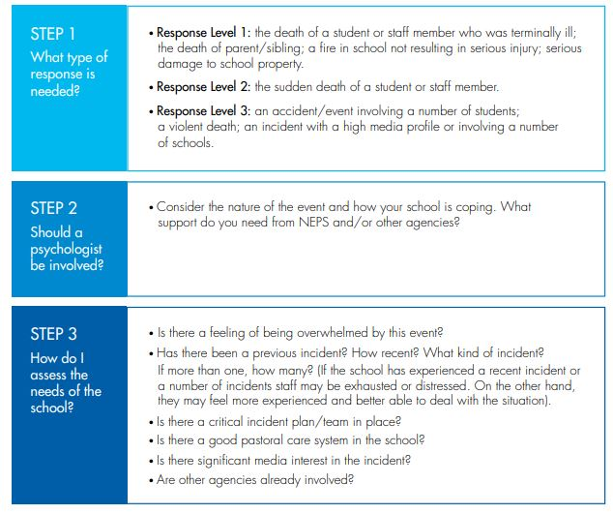

- Immediate contact with family/families
- Consult with the family regarding appropriate support from the school, e.g. funeral service
- Ensure that a quiet place can be made for students/staff
Media Briefing (if appropriate)

- Designate a spokesperson (Leader)
- Gather accurate information
- Prepare a brief statement (Team)
- Protect the family’s privacy
- It is important to obtain accurate information about the incident
- What happened, where and when?
- What is the extent of the injuries?
- How many are involved and what are their names?
- Is there a risk of further injury?
- What agencies have been contacted already?
- Contact appropriate agencies
- Emergency services
- Medical services
- H.S.E. Psychology Departments/Community Care Services
- Liaise with National Educational Psychological Service (NEPS)

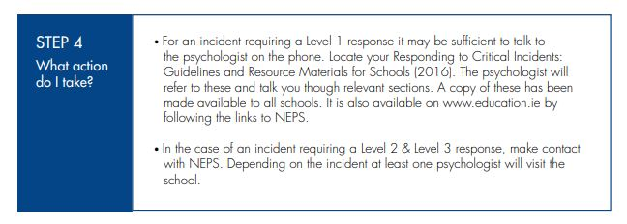

Convene a meeting with Key Staff/Critical Management Team
- Organize a staff meeting, if appropriate
- Ensure any absent staff members are kept informed
- Organise timetable/routine for the day. (Adhering to the normal school routine is important, if this is possible)
- Class teachers to take note of any absentees who might need to be contacted, list of friends etc, or any other relevant information. This is to be given to the Student Liaison person
- Arrange supervision of students
- Liaise with the family regarding funeral arrangements/memorial service
- The Chaplain/Principal will liaise with the family, to extend sympathy and clarify the family’s wishes regarding the school’s involvement in funeral/memorial service
- Arrange a home visit by two staff representatives within 24 hours, if appropriate. (Student Liaison person + Class teacher)
- Have regard for different religious traditions and faiths

MEDIUM-TERM ACTIONS (24-72 HOURS)

- Preparation of students/staff attending funeral
- Involvement of students/staff in liturgy if agreed by bereaved family
- Facilitation of students/staffs responses, e.g. Sympathy cards, flowers, Book of Condolences, etc.
- Ritual within the school
- Review the events of the first 24 hours
- Reconvene Key Staff/Critical Incident Management Team
- Decide arrangements for support meetings for parents/students/staff
- Decide on mechanism for feedback from teachers on vulnerable students
- Have review of Critical Incident Management Team meeting
- Establish contact with absent staff and pupils
- Arrange support for individual students, groups of students, and parents, if necessary
- Hold support/information meeting for parents/students, if necessary, in order to clarify what has happened
- Give any teacher who feels uncomfortable with involvement in support meetings the choice of opting out
- Arrange, in consultation, with outside agencies, individual or group debriefings or support meetings with parental permission
- Plan for the re-integration of students and staff e.g. absentees, injured, siblings, close relative etc)
- Student Liaison person to liaise with above on their return to school.
- Plan visits to injured
- Family Liaison person + Class Teacher + Principal to visit home/hospital
- Attendance and participation at funeral/memorial service (To be decided)
- Decide this in accordance with parent’s wishes, school management decisions and in consultation with close school friends
- School closure (if appropriate)
- Request a decision on this from school management

LONGER TERM ACTIONS

Monitor students for signs of continuing distress
If over a prolonged period, a student continues to display the following, he/she may need assistance from the Health Board. Constant communication with family is essential.

- Uncharacteristic behaviour
- Deterioration in academic performance
- Physical symptoms — e.g. weight loss/gain, lack of attention to appearance, tiredness, restlessness
- Inappropriate emotional reactions
- Increased absenteeism

Evaluate response to incident and amend Critical Incident Management Plan appropriately

- What went well?
- Where were the gaps?
- What was most/least helpful?
- Have all necessary onward referrals to support services been made?
- Is there any unfinished business?

Formalise the Critical Incident Plan for the future

- Consult with NEPS Psychologist
- Inform new staff/new school pupils affected by Critical Incidents where appropriate
- Ensure that new staff are aware of the school policy and procedures in this area
- Ensure they are aware of which pupils were affected in any recent incident and in what way
- When individual pupils or a class of pupils affected by an incident are transferring to a new school, the Principal should brief the Principal of the new school

Decide on appropriate ways to deal with anniversaries (Be sensitive to special days and events)

- Anniversaries may trigger emotional responses in students/staff and they may need additional support at this time
- Acknowledge the anniversary with the family
- Need to be sensitive to significant days like Birthdays, Christmas, Mother’s Day, and Father’s Day

- Plan a school memorial service
- Care of deceased person’s possessions. What are the parent’s wishes?
- Update and amend school records

11. Record Keeping
In the event of an incident, each member of the team will keep records of phone calls made and received, letters sent and received, meetings held, persons met, interventions used, material used etc. The school secretary will have a key role in receiving and logging telephone calls, sending letters, photocopying materials, etc

12. Confidentiality and Good Name Considerations
The management and staff of Scoil Naomh Mhuire have a responsibility to protect the privacy and good name of the people involved in any incident and will be sensitive to the consequences of any public statements. The members of the school staff will bear this in mind and will seek to ensure that students do so also. For instance, the term “suicide” will not be used unless there is solid information that death was due to suicide, and that the family involved consents to its use. The phrases, ‘tragic death’ or ‘sudden death’ may be used instead. Similarly, the word ‘murder’ should not be used until it is legally established that a murder was committed. The term ‘violent death’ may be used instead.

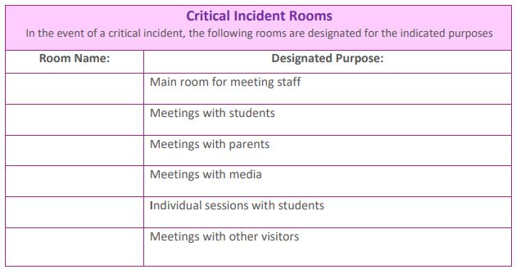

Consultation and communication regarding the plan All staff were consulted and their views canvassed in the preparation of this policy and plan. Students and parent/guardian representatives were also consulted and asked for their comments. Our school's final policy and plan in relation to responding to critical incidents has been presented to all staff. Each member of the critical incident team has a personal copy of the plan. All new and temporary staff will be informed of the details of the plan by Mr McCrink - the plan will be updated annually – October 2026

Please refer to NEPS templates and resources via –

https://www.gov.ie/en/department-of-education/services/national-educational-psychological-service-neps/#critical-incidents

NEPS Region 2 – Contact Details.
Louth
NEPS, Donore Road, Industrial Estate,
Drogheda, Co. Louth, A92 EC85
Tel: (01) 8650801 (Fiona)

Ratified by Board of Management: _________________________

Signed by : ____________________________ (Chairperson BOM) on
____________________

Signed by: ____________________________ (Principal/Secretary BOM) on
__________________

